P5 Linear Regression

(1)

$$w=\left[\begin{matrix}1.9468 \\ -2.8241\end{matrix}\right]$$

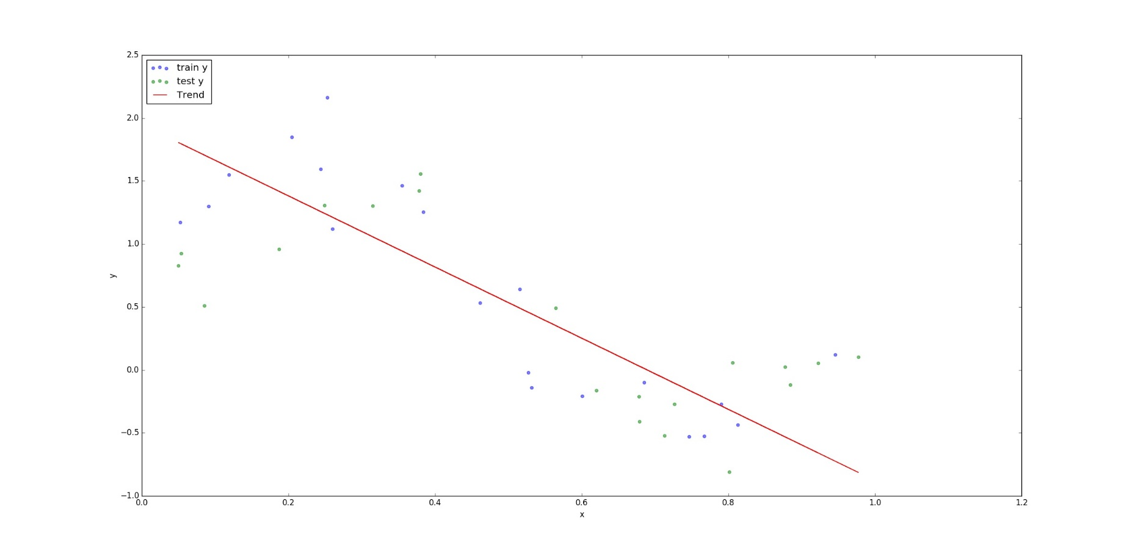

(2)

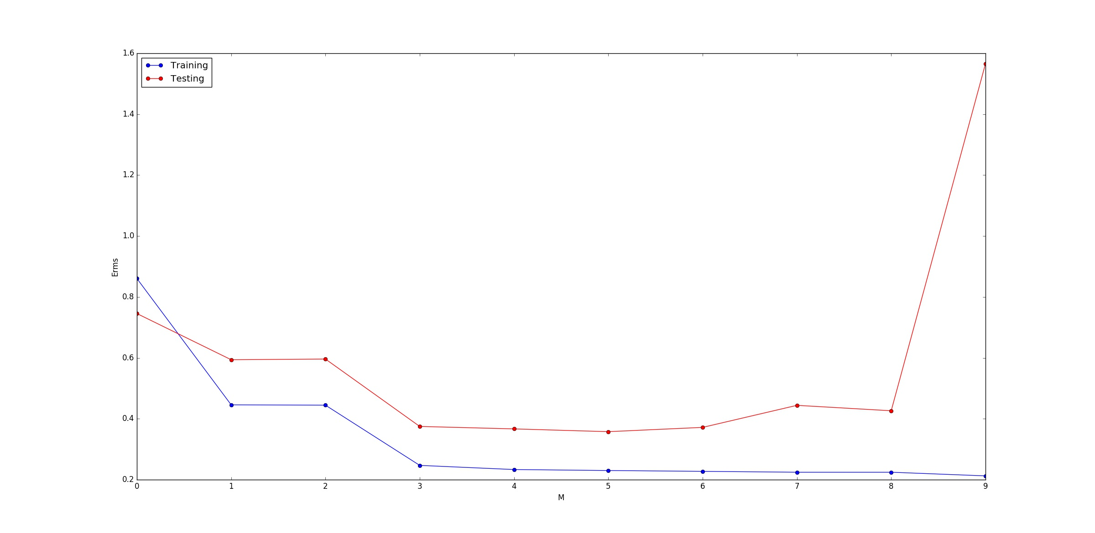

(3)

In this question, I set $λ={10}^{-6}:{10}^{13}$. The close form for regularized linear regression is

$$w=yФ^{T}{\left(ФФ^{T}+λI\right)}^{-1}$$

Where Ф is a 9th degree polynomial of x.

